## 1. Function Overview

To enable data exchange with third-party systems, this feature allows users to configure relevant information on the settings page—such as the IP address, port number, pull path, and upload path—to perform patient information import and export operations.

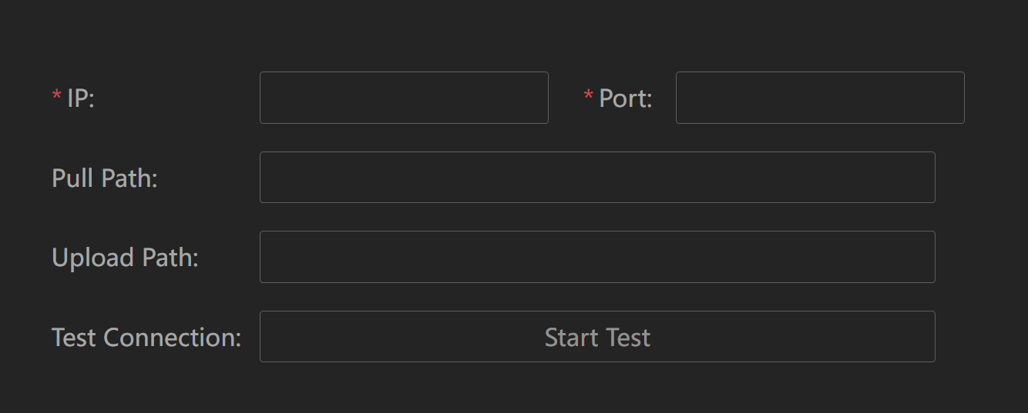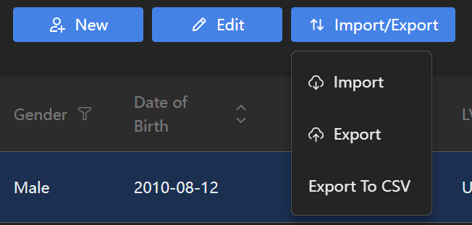

## 2. Configuration Item Description

On the settings page of the user interface, users need to configure the following parameters:

| **Configuration Item** | **Description** | **Example** | **Notes** |
| --- | --- | --- | --- |
| IP Address | Service IP address provided by the third-party system | 192.168.1.100 | Required. Ensure network connectivity. |
| Port Number | Port number opened by the third-party system | 8080 | Required. Must be confirmed with the third party. |
| Pull Path | API path for fetching patient information | /getPatients | Required. Specific path provided by the third party. |
| Upload Path | API path for uploading data | /setPatients | Required. Specific path provided by the third party. |

## 3. API Definition

### Import API (GET Request)

**Request URL Construction**:  
Based on the IP address, port number, and pull path provided by the user, the system will automatically construct the request URL. For example:  
http://{IP}:{Port}/{FetchPath}  
Example: http://192.168.1.100:8080/getPatients

**Request Method**:  
GET

**Request Headers**:  
No additional headers are required. The default HTTP/1.1 standard headers will be used.

**Request Parameters**:

Parameters are passed through the URL query string (if needed). For example:  
http://192.168.1.100:8080/getPatients?startDate=2022-01-01&endDate=2022-12-31

Specific parameters are defined by the third-party system.

**Response Data Format**:  
The response data is in JSON format and contains a list of patient information.

Detailed documentation can be found in:

getPatients-zh.md

getPatients-en.md

### Export API (POST Request)

**Request URL Construction**:  
Based on the IP address, port number, and upload path provided by the user, the system will automatically construct the upload API request URL. For example:  
http://{IP}:{Port}/{UploadPath}  
Example: http://192.168.1.100:8080/setPatients

**Request Method**:  
POST

For detailed documentation, please refer to

setPatients-zh.md

AL550ExportFile-ZH.md

## 4. Error Handling and Exception Cases

**Network Exception**:  
If a network issue occurs during the request process, such as a connection timeout or inability to access the target server, the system will return a network exception message.

**Data Format Issues**:  
If the data format does not meet the API requirements (e.g., the imported data is not in JSON format, or the exported data cannot be converted into XML format), the system will return a 400 error along with a detailed error description.

**API Call Failure**:  
If the third-party system returns an error message, the system will log the relevant error and provide a user-friendly error message to the user.

## System Integration Process

· The user fills in the relevant configuration items—IP address, port number, pull path, and upload path—on the system settings page.

· The user clicks the "Import" button, and the system automatically constructs a GET request and initiates the request to grab patient information.

· The user clicks the "Export" button, and the system constructs a POST request to upload the XML file.

· The system provides appropriate feedback and handles responses or error messages returned by the third-party system.

## 6. Precautions

**Path Format**:  
Ensure that the pull path and upload path are correct, especially regarding whether a trailing slash is required at the end of the path.

**Data Structure Consistency**:  
Ensure that the imported patient data matches the system's data structure to avoid errors caused by mismatched fields.

**Upload Data Volume**:  
When uploading a large amount of data, be mindful of the system's performance and consider performing batch uploads if necessary.